Submit to: **pkisambira@ucu.ac.ug**

**spreadsheet Exercis****es**



Exercise 1

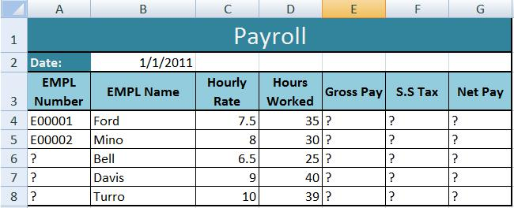

1. Open a new workbook and save the file with the name “Payroll”.
2. Enter the labels and values in the exact cells locations as desired.
3. Use AutoFill to put the Employee Numbers into cells A6:A8.
4. Set the columns width and rows height appropriately.
5. Set labels alignment appropriately.
6. Use warp text and merge cells as desired.
7. Apply borders, gridlines and shading to the table as desired.
8. Format cell B2 to Short Date format.
9. Format cells E4:G8 to include dollar sign with two decimal places.
10. Calculate the Gross Pay for employee; enter a formula in cell E4 to multiply Hourly Rate by Hours Worked.
11. Calculate the Social Security Tax (S.S Tax), which is 6% of the Gross Pay; enter a formula in cell F4 to multiply Gross Pay by 6%.
12. Calculate the Net Pay; enter a formula in cell G4 to subtract Social Security Tax from Gross Pay.
13. Set the work sheet vertically and horizontally on the page.
14. Save your work.



Exercise 2

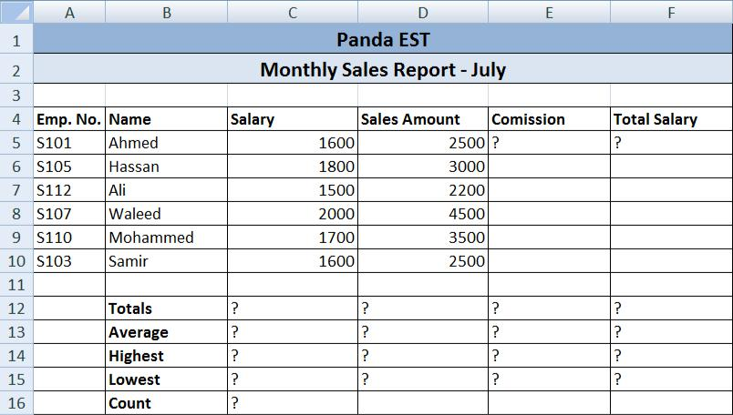

1. Create the worksheet shown above.
2. Set the **column widths** as follows: Column A: 8, Column B: 14, Columns C & D: 15,

Columns E & F: 14.

1. Enter the formula to find COMMISSION for the first employee. The commission rate is 2% of sales, **COMMISSION = SALES * 2%** Copy the formula to the remaining employees.
2. Enter the formula to find TOTAL SALARY for the first employee where:

**TOTAL SALARY = SALARY + COMMISSION** Copy the formula to the remaining employees.

1. Enter formula to find **TOTALS**, **AVERAGE**, **HIGHEST**, **LOWEST**, and **COUNT** values. Copy the formula to each column.
2. Format numeric data to include **commas** and **two decimal places**.
3. Align all column title labels horizontally and vertically **at the center**.
4. Create a **Header** that includes your name in the left section, page number in the center section, and your ID number in the right section.
5. Create **footer** with DATE in the left section and TIME in the right section.
6. Save the file with name Exercise2.